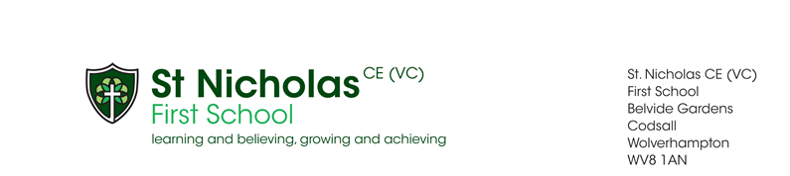
sla
Walking in the footsteps of Jesus with Respect, Perseverance, Care, Trust and Thankfulness.

4th October 2024

To whom it may concern

RE: Consultation on admission arrangements 2026/2027

Codsall Multi Academy Trust wishes to formally consult with you regarding
St Nicholas First School’s admissions arrangements for 2026/2027.

We are not proposing to make any material changes to the current arrangements.

However, in accordance with the DfE’s 2021 statutory ‘School Admissions
Code’ guidance, we must consult once every seven years. Your opinions
important to us and we are keen to receive your comments on the
arrangements before they are formally approved.

A full copy of the proposed admission arrangements is available on our
website: Proposed Admission Arrangements 2026-2027

The consultation will close on Thursday 14th November 2024.

Please send your comments to: Mrs Kilvert via email at office@st-nicholas.staffs.sch.uk

Yours sincerely
Miss J Parker
Headteacher

